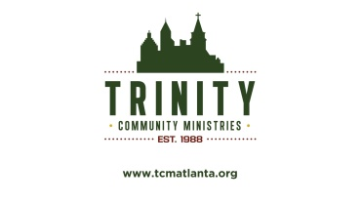 Trinity Community Ministries Marketing and Media Consent Form

I, ____________________________ grant permission to Trinity Community Ministries and its employees the right to reproduce the photographs and/or video imaged taken of me or members of my family for the purpose of publication, promotion, illustration, and advertising or in any many that will promote the mission of Trinity Community Ministries. I hereby release Trinity Community Ministries and staff for all claims and liability relating to said images or video. I grant permission to use my statements that were given during an interview or guest lecture, with or without my name for the purpose of advertising and publicity without restriction. I waive my right to any compensation.

I acknowledge that I am [ ] over the age of 18
[ ] the legal guardian of the following

If legal guardian of guest(s), please list the names here:
Name(s):__________________________________________
Signature: ___________________________________________ Date: __________
Address: ______________________________________________
_____________________________________________

